OFFICIAL COORDINATION REQUEST FOR
NON-ROUTINE OPERATIONS AND MAINTENANCE

COORDINATION TITLE- 16BON03
COORDINATION DATE- 2/1/2016
PROJECT- Bonneville Dam
RESPONSE DATE- 2/11/2016

Description of the problem – A recent ROV inspection discovered that a diffuser panel has blown off in the PH2 collection channel at diffuser C4 (photo below), which sits in the middle of the collection channel. Currently the project has closed diffuser C4, which is the only opening between the diffuser pit (which sits underneath the grating) and the AWS conduit. Thus fish are currently able to enter the diffuser pit but not the AWS conduit.

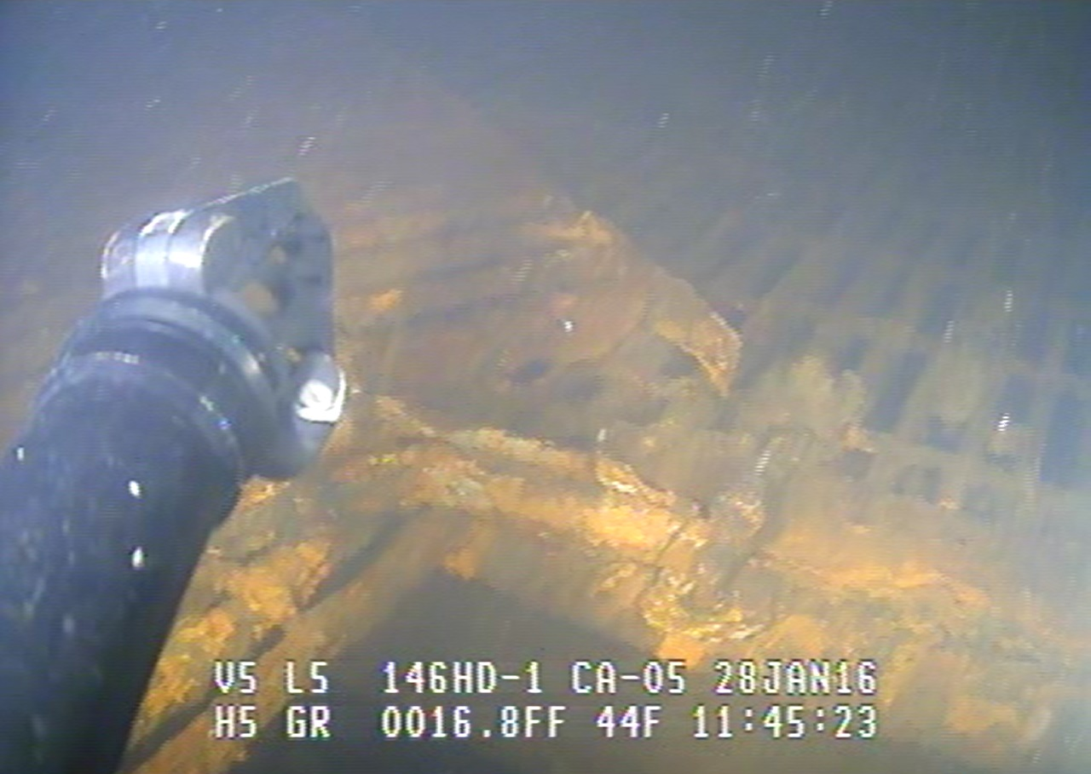

Type of outage required – There are 3 potential actions and each one requires a different outage and creates a different impact.
- Bring in divers to repair while watered up. This would require a partial shutdown of the ladder to install transverse bulkheads in the south half of the collection channel. Floating orifice gate would also likely need to be closed in that section or perhaps a change in unit priority to create non-turbulent work environment. The south fishway entrances would not be viable fish passage routes during this work window. The scope of the repairs (cutting off studs and attaching new grating) means the USACE dive office will not be able to do this work. Professional divers will need a contract, putting the potential time for dive repairs in mid-March at the earliest.
- Isolate the area and dry it up. This would also make the south entrances impassable. It is likely the longest outage as it could take 7-10 days to isolate, repair, and water back up. It does, however, allow for the best repair. BON Project estimates this option would take 7-10 days and cost ~$30,000-35,000. Due to a lack of personnel availability due to ongoing winter maintenance at Bradford Is, the earliest this repair could occur is early March.
- Continue the current operations (fish valve C4 closed) and wait until next winter maintenance (winter of 2016-17) to repair in the dry. This would do away with any attraction flow so it would likely not draw fish into it, and if they did go in they could only go into the immediate diffuser area.

Impact on facility operation –
- PH2 would likely need to be taken OOS during the daytime hours for dive work. The actual work would likely take no more than a few days.
- Partial closure of the WA shore fishway for the duration of the repair. This section of the PH2CC fishway would be bulkheaded off, leaving the south entrances of PH2 cut off from the rest of the fishway; thus only the north entrances would be available to fish during the repairs.
- None. Diffuser C4 would not be operational. This diffuser is one of 10 along the collection channel. A hydraulic impact has not been assessed to date.

Dates of impacts/repairs- Dives would likely complete this work in a couple of days. Dewatering the C4 section of the PH2CC would take ~7 – 10 days.

Length of time for repairs- Variable based on option chosen

Expected impacts on fish passage-To be determined based on option chosen. If FPOM would like immediate repairs by the Project (option 2), 10-year averages for WA shore fish passage for 1 – 14 March are provided in Table 1:

Table 1: Ten-year average (2006-2015) adult salmonid passage for WA shore.
Date | All Chinook | Adult Chinook | Jack Chinook | All Steelhead | Clipped Steelhead | Unclipped Steelhead | Totals
1-Mar | 0 | 0 | 0 | 20 | 13 | 7 | 40
2-Mar | 0 | 0 | 0 | 13 | 8 | 5 | 26
3-Mar | 1 | 1 | 0 | 14 | 9 | 5 | 31
4-Mar | 1 | 1 | 0 | 19 | 12 | 7 | 40
5-Mar | 1 | 1 | 0 | 27 | 19 | 9 | 56
6-Mar | 1 | 1 | 0 | 27 | 15 | 12 | 56
7-Mar | 2 | 1 | 0 | 22 | 15 | 7 | 47
8-Mar | 1 | 1 | 0 | 17 | 12 | 6 | 37
9-Mar | 1 | 1 | 0 | 20 | 14 | 6 | 43
10-Mar | 3 | 3 | 0 | 26 | 17 | 9 | 59
11-Mar | 3 | 3 | 0 | 26 | 18 | 9 | 58
12-Mar | 3 | 3 | 0 | 28 | 19 | 9 | 63
13-Mar | 1 | 1 | 0 | 20 | 10 | 10 | 42
14-Mar | 1 | 1 | 0 | 34 | 23 | 11 | 70
total | 4 | 4 | 0 | 48 | 34 | 14 | 104

Comments from agencies

Final results

Please email or call with questions or concerns.
Thank you,
Ida

Ida Royer
NWP Operations Division Fishery Section
Columbia River Coordination Biologist
Ida.M.Royer@usace.army.mil

